ARANMORE CATHOLIC COLLEGE

YEAR 12 PHYSICS 3A3B

MOTION TOPIC TEST 2

NAME: ____________________________________ MARK:
/50

Instructions:

- Answer all questions in the spaces provided on the test paper.
- Show full working out to get full marks as shown in brackets after each question.
- Calculators as per Curriculum Council guidelines are permitted.
- Answers must be in blue or black ink.

Questions:

- Would a planet with twice the Earths’ mass and twice the Earths’ radius have the same acceleration due to gravity at its surface as the Earth? Explain your answer. [3 marks]

- Explain the difference between apparent weightlessness and true weightlessness. [3 marks]

- Joe was given the task of designing a drinking cup for a small child. He came up with a design of a short cup with a wide base. With the aid of diagrams explain the physics behind Joe’s design. [4 marks]

- A spherical asteroid, T307 has a mass of 8.50 x 10¹⁷ kg and a radius of 299 km. [4 marks each]
a) Calculate the gravitational field strength at the surface of asteroid T307.

b) Determine the speed of a satellite in orbit at a height of 25.0 km above the surface of asteroid T307.

- Perth television stations can use pictures from the Japanese GMS weather satellite which is in geostationary orbit over the equator to the north of Australia. Why is it not possible to place the satellite directly over Perth?
[3 marks]

- Chad parks his bus part-way along a bridge that is supported by two pillars, as shown in the diagram below. The 22.0 m bridge is uniform and has a mass of 32.0 tonne. The bus has a mass of 12.5 tonne and its centre of mass is 8.50 m from the left end of the bridge. Find the force exerted by each pillar. [5 marks]
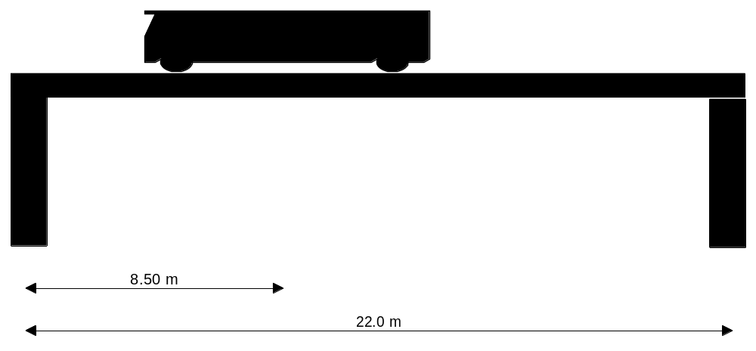

- A sign outside Jake’s hardware shop is suspended from a uniform beam ABC, which is 2.10 m long and has a mass of 20.0 kg. The beam is suspended by two identical wires attached at A and B. The tensions in the two wires are 50.0 N and 200.0 N respectively (see the diagram below).
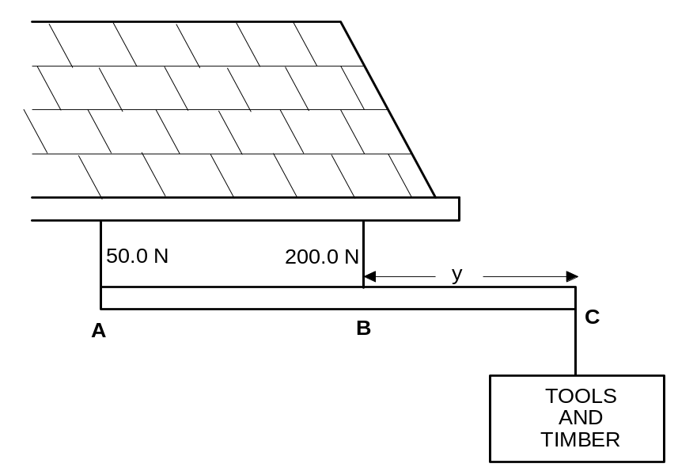

a) What is the weight of the sign ‘Tools and Timber’? [3 marks]

b) What is the distance ‘y’? [5 marks]

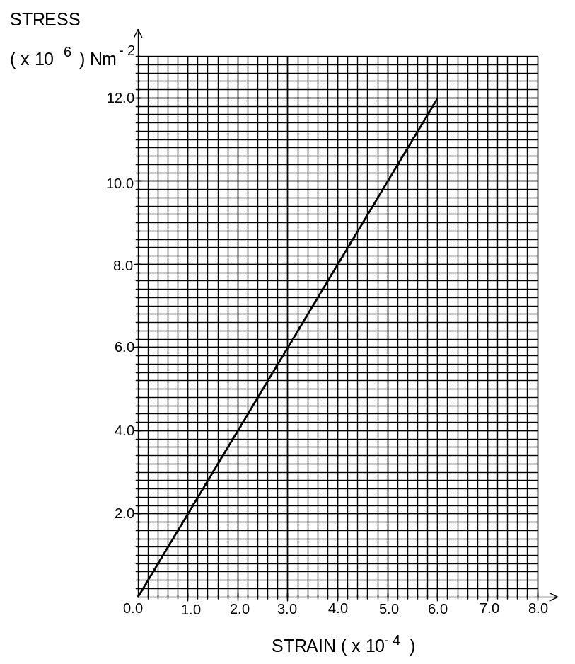

- Describe and compare rotational and translational equilibrium. What are the conditions required for static equilibrium? [4 marks]

- A uniform, 3.40 m ladder of weight 110 N, is leaning against a building. (Assume that the ground is rough and the wall is smooth, i.e. the reaction force will be perpendicular.) The ladder makes an angle of 65º with the ground and Vinh, who weighs 690 N, is standing on a rung halfway up the ladder in order to paint a nearby window frame. Find the reaction force at the ground. [6 marks]

PART B [6 Marks]
BALLET (Article adapted from: Scientific America.)

A large part of the early skills a ballet dancer must learn is to maintain balance while moving gracefully through the ballet forms. Balance is achieved when an area of support lies in an appropriate plane below the dancer’s body. If the support area is off to one side, gravity pulls or turns the dancer towards the floor.
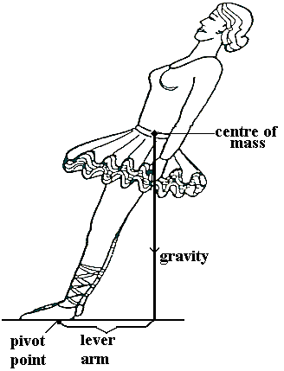Gravity, of course, pulls constantly on every part of the body, but the concept of a centre of mass of the body helps to simplify the picture. The centre of mass is a mathematical point whose position is determined by the distribution of mass within the body. The combined pull of gravity on all the parts of the body is said to operate through the centre of mass.

When that centre is not over a support area on the floor, the pull of gravity creates a torque on the body (see above). The torque arising from the tilt tends to rotate the body about the feet. The greater the tilt, the longer the lever arm and a stronger torque is therefore produced. If the dancer stood upright, the length of the lever arm would be zero and gravity would create zero torque; the position would be stable.

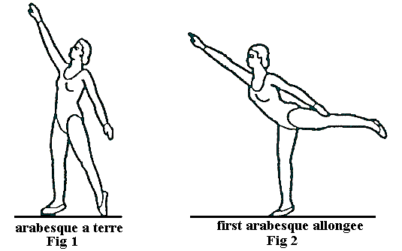The routine for the beginning student seeks to develop a sense of balance gradually. The position called the arabesque is a simple first version and is then advanced to the first arabesque penchee. In the simple version (Fig 1: arabesque a terre) the right leg is put forward, the left leg back with the toes touching the floor; the weight is therefore on the right leg. The arm reaches forward, the left arm slightly backwards.
Moving the left leg to the rear shifts the centre of mass in that direction. Without a compensating movement the dancer would fall over backward. To shift the centre of mass back over the support area of the right foot the dancer must lean forward and extend the right arm. This motion serves two purposes: it is graceful and it ensures balance is maintained. Fig 2 above shows the dancer moving from the arabesque a terre to the first arabesque allongee.

In the first arabesque allongee the dancer continues the motion until the torso and right arm are almost horizontal and the rear leg is tilted upward. In the first arabesque penchee (Fig 3 below) the dancer’s torso and right arm are tilted downward and the rear leg is tilted upward at 45 º or more. In both forms of the position the mass moved rearward by the leg must be matched by the mass shifted forward by means of leaning the torso and extending the arm. Only then will the centre of mass remain over the support area so that the dancer is stable.
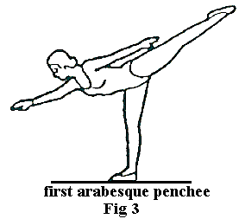
a) Explain, in terms of the principle of moments (torques), the conditions necessary for equilibrium to be maintained for a dancer. [2 marks]

b) Explain why the first arabesque a terre position is easier for a beginning dancer to maintain than the more advanced arabesque penchee position. [2 marks]

c) Compare the position of centre of mass of the dancer in the first arabesque a terre position and the first arabesque penchee position. [2 marks]

*****************************************
END OF TEST

